Practical 2
Aim
To install Oracle VirtualBox on a Windows operating system and verify its successful installation.
Requirements
- Windows 10/11 computer
- 64-bit processor and operating system
- Minimum 4 GB RAM
- Sufficient free storage
- Internet connection
- VirtualBox installer
Procedure
Step 1: Download VirtualBox
- Open a web browser on Windows.
- Visit the official Oracle VirtualBox website.

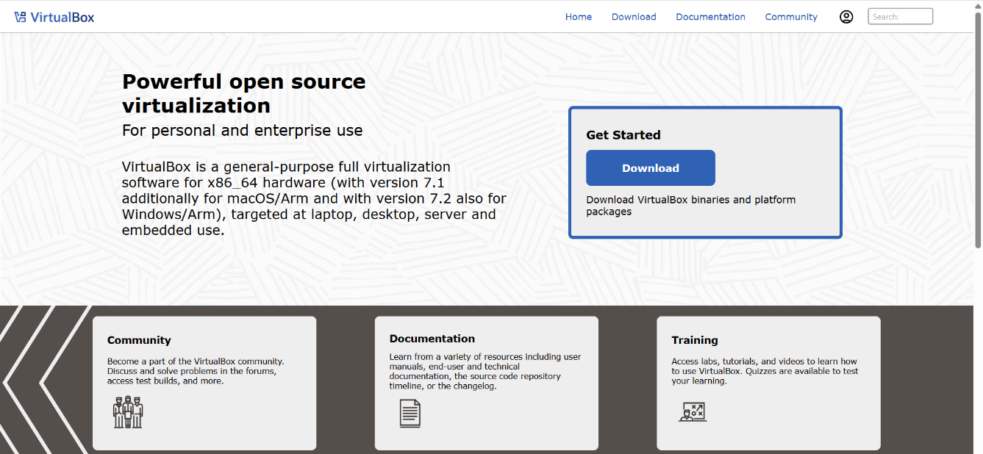
- Go to the Downloads section.

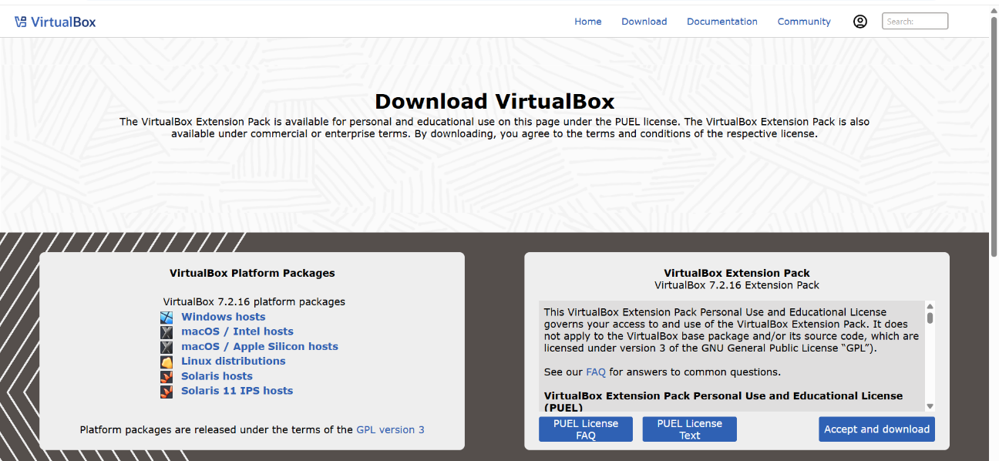
- Select Windows hosts to download the Windows installer.
Step 2: Start Installation
- Locate the downloaded .exe installer.

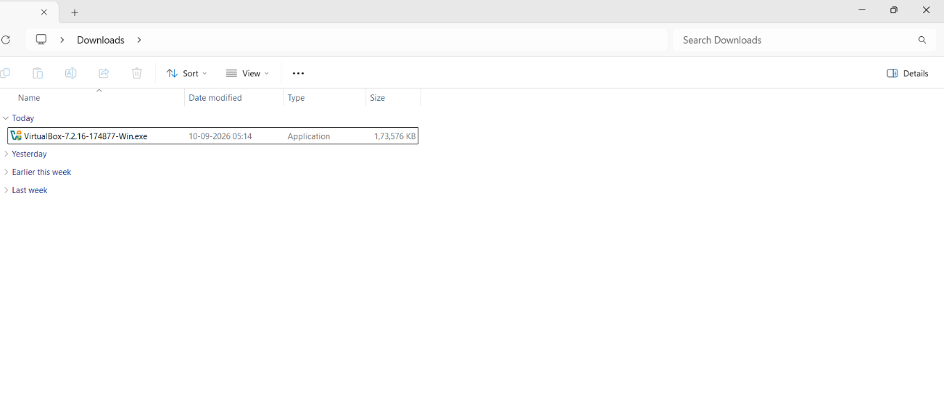
- Double-click the installer.
- If Windows displays a security prompt, select Yes.
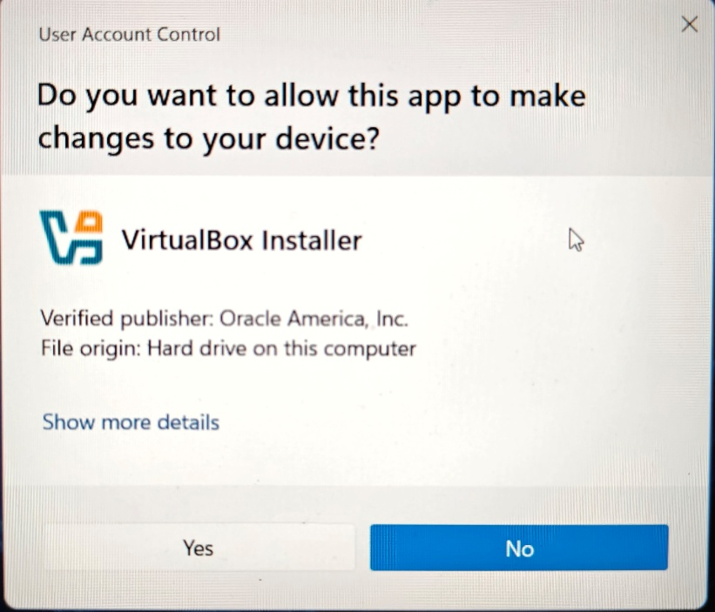
- The VirtualBox Setup window will appear.

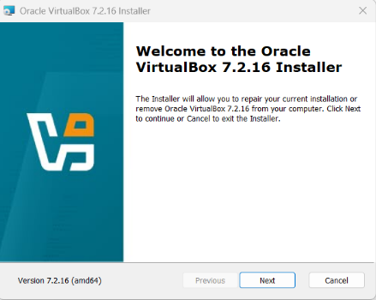
- Click Next.

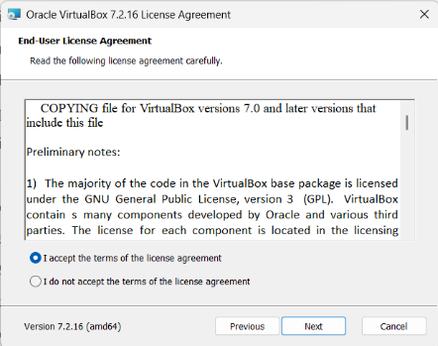
Step 3: Select Components
- Keep the default components selected.
- Choose the installation location if required.

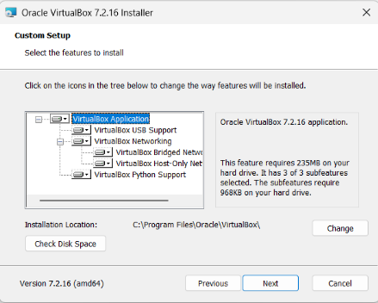
- Click Next.
Step 4: Configure Installation Options
- Keep the default options for shortcuts and file associations.
- Click Next.
- A warning about network interfaces may appear because VirtualBox needs to install virtual networking components.

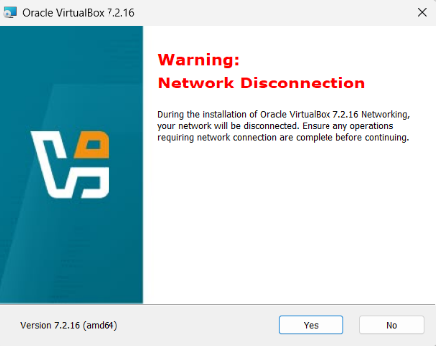
- Click Yes to continue.
Step 5: Install VirtualBox
- Click Install.
- Wait while the required files and drivers are installed.
- If Windows asks for permission to install device software, allow the installation.
- After the installation is complete, click Finish.

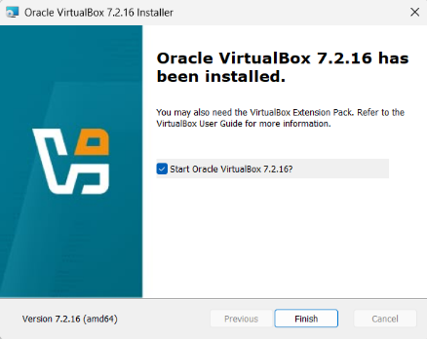
Step 6: Verify Installation
- Open Oracle VM VirtualBox from the Start Menu.

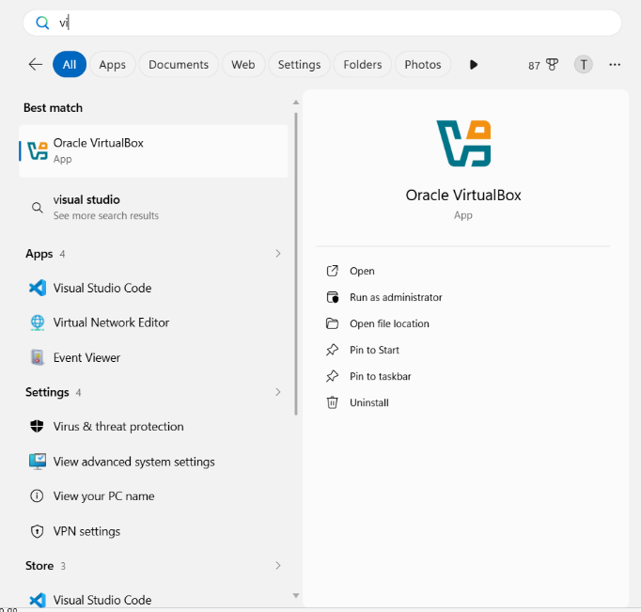
- The VirtualBox Manager window should appear.
- Verify that options such as New, Settings, and Start are available.

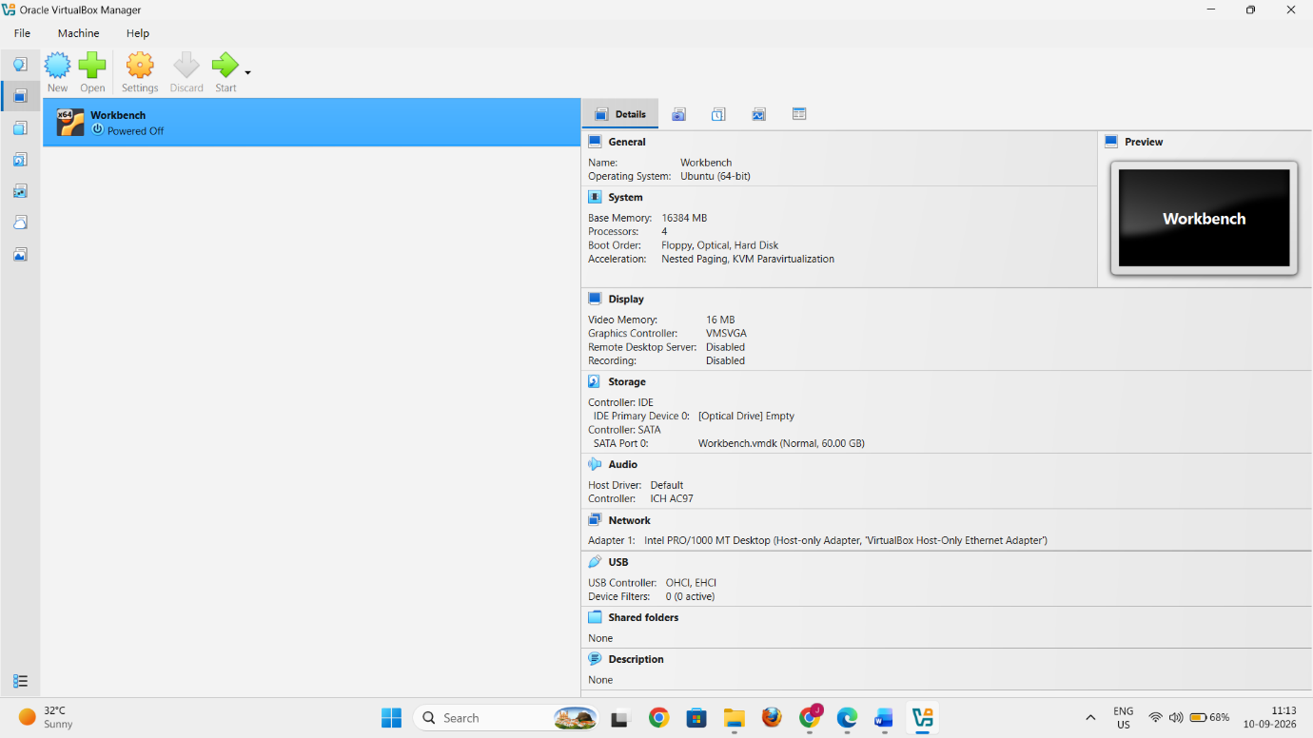
- The successful opening of VirtualBox confirms that the installation was completed.
Result
Oracle VirtualBox was successfully installed and verified on the Windows operating system.

